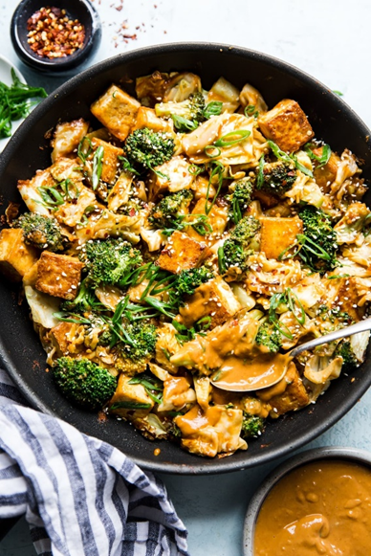Tofu Stir-Fry with Peanut Sauce

|  |
| --- |
| Ingredients With Measurements **Peanut Sauce**   * 1 tablespoon fresh ginger, minced or grated * 1 large garlic cloves, minced * ½ cup natural peanut butter (unsalted) * ¼ cup low-sodium soy sauce * ¼ cup water * 3 tablespoon apple cider vinegar * 1 teaspoon sriracha * 2 tablespoon toasted sesame oil * 2 tablespoon canola oil   **Meal**   * 1 (14 oz) package extra firm tofu, drained on a towel and cut into 1 inch cubes * 2 cups roughly chopped cabbage * 1 small head of broccoli, cut into florets |

|  |
| --- |
| Recipe Combine all peanut sauce ingredients in a food processor or blender, and blend until the peanut sauce is smooth, cohesive and creamy, about 30 seconds.  In a large skillet or wok, warm the oil over medium-high heat. Add the tofu, and let it fry for a few minutes on each side, about 10-12 minutes total. When the tofu has gotten crispy remove from pan and set aside on a paper towel lined plate.  In the same skillet add the cabbage and broccoli, and sauté until the vegetables are soft and tender, about 8 minutes. Turn the heat down to medium, return tofu to the skillet and add the peanut sauce. Toss to coat and allow to cook for another 1-2 minutes. |

|  |  |  |  |  |  |  |  |  |  |  |  |  |
| --- | --- | --- | --- | --- | --- | --- | --- | --- | --- | --- | --- | --- |
| |  |  |  | | --- | --- | --- | | Fresh Ginger | Garlic | Natural Peanut Butter | | Low-Sodium Soy Sauce | Water | Apple Cider Vinegar | | Sriracha | Toasted Sesame Oil | Canola Oil | | Extra Firm Tofu | Cabbage | Broccoli |  Ingredients Without Measurements |